# Exercise 1: Downloading and installing Node.js and npm

**Objectives and Outcomes**

Node.js is a server-side JavaScript code execution environment, while npm (Node Package Manager) is a package management tool for Node.js. To develop JavaScript applications or run Node.js-related tools, you need to download and install both Node.js and npm on your computer. At the end of this exercise, you would be able to:

Installing Node.js and npm

**Installing Node**

Downloading and installing Node.js and npm includes the following steps:

* Download the Node.js installation package from the official website.
* Run the installation package and follow the on-screen instructions to complete the installation.
* Verify the installation was successful by opening a terminal and running the Node.js and npm version check commands.

**Guidelines**

**Step 1:** Visit the official Node.js website (<https://nodejs.org>).

**Step 2:** On the website, you will see two recommended Node.js versions: LTS (Long-Term Support) and Current. For general purposes, choose the LTS version for stability and long-term support.

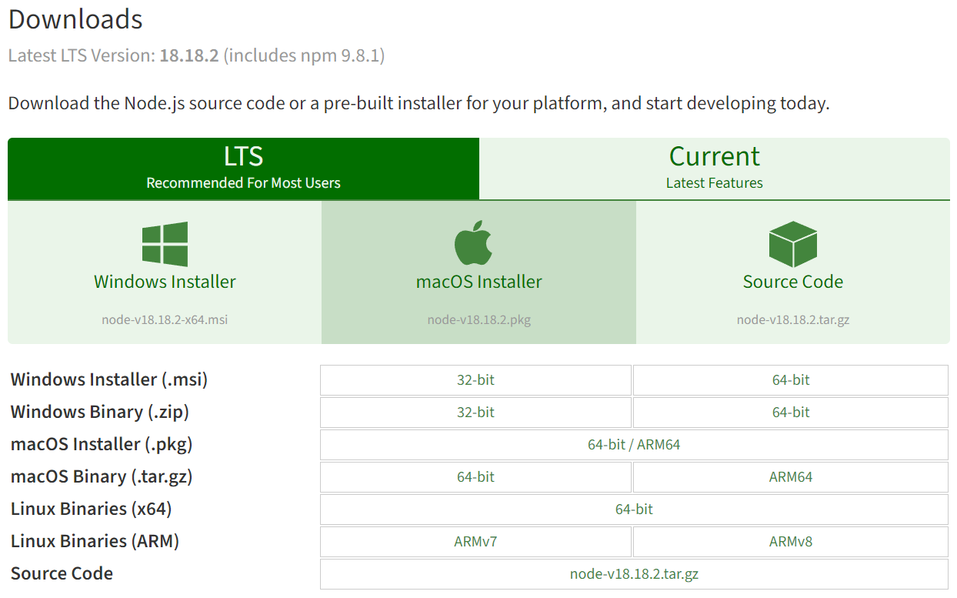

**Step 3:** Click on the Node.js LTS version to download the installation package.

**Step 4:** Once the installation file has been downloaded, run the installation file to start the installation process.

**For Windows**: Double-click the installation file (.msi) and follow the onscreen instructions. Select the appropriate installation path and options.

**For macOS**: Open the installation file (.pkg) and follow the onscreen instructions. Select the appropriate installation path and options.

**For Linux**: Open terminal, navigate to the directory containing the installation files and run the following command to install:

sudo dpkg -i installation_filename.deb

(Replace "installation_filename.deb" with the actual name of the installation file you downloaded)

**Step 5:** Once the installation is complete, check the installed Node.js version by opening a terminal and running the following command:

node -v

If the Node.js version is displayed, the installation was successful.

**Step 6:** Next, to test the npm installation, run the following command in terminal:

npm -v

If the npm version shows up, the installation was successful.

**Conclusions**

Downloading and installing Node.js and npm is an important process for developing and running Node.js-related JavaScript applications. By following the above instructions, you can successfully set up a Node.js development environment on your computer.